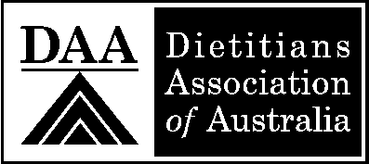

Mutual Recognition Voluntary Relationship Charter Verification Form

Applicants Name: Date of Request:
The above dietitian is a member in good standing with:
  - The Dietitians Association of Australia
    - Membership Number:
    - Full APD Status Yes No
  - Provincial Dietetic Regulatory Body in Canada.
    - Name of the Dietetic Regulatory Body:
    - Registration Number:
    - Class of Registration:
    - Date of First Registration:
- Indicate whether this applicant:
  - Is subject to a current or previous complaint, investigation, disciplinary or fitness to practice hearing conducted by either DAA or a Canadian Dietetic Regulatory Body.
YES NO
If yes, provide details:
- Is subject to any conditions, restrictions, or limitations on their practice imposed by DAA or a Canadian Dietetic Regulatory Body.
YES NO
If yes, provide details:
- Is subject to internal procedures that may affect standing or bring into question the applicant’s ability to practice lawfully and safely, such as: Non-payment of Fees; Non Compliance with Continuing Competency Program.
YES NO
If yes, provide details:
- Is subject to other procedures that may affect standing or bring into question the applicant’s ability to practice lawfully and safely, such as: Criminal Investigation; Malpractice Conviction (Civil)
YES NO Not known by DAA or Regulatory Body
If yes, provide details:
DAA |  | Provincial Dietetic Regulatory Body
Current APD Accreditation Period Expiry Date |  | Current Registration Expiry Date
Signature of Authorized Person |  | Signature of Authorized Person
Name |  | Name
Position |  | Position
Date (dd/mm/yr) |  | Date (dd/mm/yr)

Documents Attached
Certified copy of Academic Transcript | Certified copy of completion of practical training education (if not fully contained in the academic transcript)
Current Registration or APD certificate as applicable
Seal of DAA or Regulatory Body

Instructions:
- Please complete and sign the form.
- Affix licensing/regulatory board seal and place as indicated in the space above.
- Scan and email the form to: registration@collegeofdietitians.org or mail the form to:
College of Dietitians of Ontario, 1810-5775 Yonge Street, Box 30, Toronto, ON M2M 4J1, Canada
- This form is valid for 90 days.

